# Control Statements

## Exercises

### Week 3

Prior to attempting these exercises ensure you have read the lecture notes and/or viewed the video, and followed the practical. You may wish to use the Python interpreter in interactive mode to help work out the solutions to some of the questions.

Download and store this document within your own filespace, so the contents can be edited. You will be able to refer to it during the test in Week 6.

Enter your answers directly into the highlighted boxes.

For more information about the module delivery, assessment and feedback please refer to the module within the MyBeckett portal.

**_________________________________________________________________________**

## ©2021 Mark Dixon / Tony Jenkins

What is the *data type* of the result when evaluating comparison (relational) expressions such as < and >?

*Answer:*

bool

**_________________________________________________________________________**

For each of the following expressions write the result of their evaluation.

100 < 101

*Answer:*

True

100 > 99

*Answer:*

True

100 >= 100

*Answer:*

True

100 != 100

*Answer:*

False

**_________________________________________________________________________**

For each of the following expressions write the result of their evaluation.

"abc" < "xyz"

*Answer:*

True

"abc" < "XYZ"

*Answer:*

False

"100" == 100

*Answer:*

Fasle

**_________________________________________________________________________**

For each of the following expressions write the result of their evaluation.

10 > 20 and 10 >= 10

*Answer:*

Fase

10 > 30 > 20

*Answer:*

Fasle

40 < 20 or 20 < 30

*Answer:*

True

not True

*Answer:*

False

**_________________________________________________________________________**

What would be the output shown following the execution of the following Python statements?

colours = [ "Blue", "Black", "Orange" ]

print("The colour black is in the list : ", "Black" in colours)

*Answer:*

The colour black is in the list : True

print("The colour orange is in the list : ", "orange" in colours)

*Answer:*

The colour orange is in the list : False

**_________________________________________________________________________**

Which of the following concepts does the Python ‘if’ statement support?

**Sequence**, **Selection** or **Iteration**?

*Answer:*

Selection

**_________________________________________________________________________**

What would be the output shown following the execution of the following Python statements?

num1 = 100

num2 = 10

if num1 % num2 == 0:

print("num1 is divisible by num2")

else:

print("num1 is not divisible by num2")

*Answer:*

num1 is divisible by num2

**________________________________________________________________________**

What would be the output shown following the execution of the following Python statements?

num1 = 99

num2 = 70

if num1 < num2:

print("num1 is less than num2")

elif num1 > num2:

print("num1 is greater than num2")

else:

print("num1 is equal to num2")

*Answer:*

num1 is greater than num2

**_________________________________________________________________________**

What is the name given to the following type of Python operator shown below?

lowest = x if x < y else y

*Answer:*

Comparison operator Chaining

And, what value would be assigned to the variable ‘lowest’ when ‘x’ was equal to 10 and ‘y’ was equal to 5?

*Answer:*

5

**_________________________________________________________________________**

Within the answer box below write a small Python program, that asks the user to enter a value between 1 and 10.

Once the value has been input display a message saying whether the value was in the requested range.

Remember: values returned from the **input()** function are *strings*, and need converting before being used within expressions, i.e. you will need code such as this -

num = input("please enter a number between 1 and 10 : ")

num = int(num)

*Answer:*

num1 = int(input(“Enter a number between 1 and 10 : ”))

if num1 > 10:

print(“Out of range.”)

else:

print(num1)

**_______________________________________________________________________**

Within the answer box below write a small Python program that asks the user to enter two values. Store these in variables called x and y respectively.

If the 'x' value is larger than 'y' then print

The value 'x' is larger than the value 'y'

otherwise print

The value 'y' is larger than the value 'x'

*Answer:*

x = input("Enter a value 1: ")

y = input("Enter a value 2: ")

if x > y:

print("The value 'x' is larger then the value 'y'")

else:

print("The value 'y' is larger then the value 'x'")

Examine the output generated by the above program. Is the displayed text entirely accurate in all cases? If not Why?

*Answer:*

Yes.

**_________________________________________________________________________**

Within the answer box below write a small Python program that asks the user to enter two values.

Store these values in two variables then output a message displaying the result of dividing the first value by the second value.

Include code that prevents a run-time error being reported when the user inputs a value of '0' for the second input. *Hint:* use an ‘if’ statement

If a '0' value is input, print a message saying "division by 0 is not possible".

*Answer:*

x = int(input("Enter a value 1: "))

y = int(input("Enter a value 2: "))

if x / y :

print("division successful")

elif x == 0 or y == 0:

print("division by 0 is not possible")

else:

print("Not possible")

**_________________________________________________________________________**

**Sequence**, **Selection** or **Iteration**?

*Answer:*

Iteeration

**_________________________________________________________________________**

What would be the output shown following the execution of the following Python statements?

num = 5

while num > 0:

print(num)

num -= 1

*Answer:*

5

4

3

2

1

**_________________________________________________________________________**

Write a small Python program that prints your name to the screen 100 times, then enter the program into the answer box below. Hint: use a ‘while’ loop.

*Answer:*

name = input("enter your name :")

a = 1

while a <= 100:

print(name)

a += 1

**________________________________________________________________________**

What would be the output shown following the execution of the following Python statements?

vals = ["A", "B", "C", "D"]

for letter in vals:

print(letter)

*Answer:*

A

B

C

D

**_________________________________________________________________________**

What would be the output shown following the execution of each of the following Python statements?

for num in range(5):

print(num)

*Answer:*

0

1

2

3

4

for num in range(10,16):

print(num)

*Answer:*

10

11

12

13

14

15

for num in range(0,10,-1):

print(num)

*Answer:*

null

**_________________________________________________________________________**

Enter and execute the python code shown below, then show the exact output into the answer box.

for x in range(1,10):

for y in range (1,x):

print("*")

print()

*Answer:*

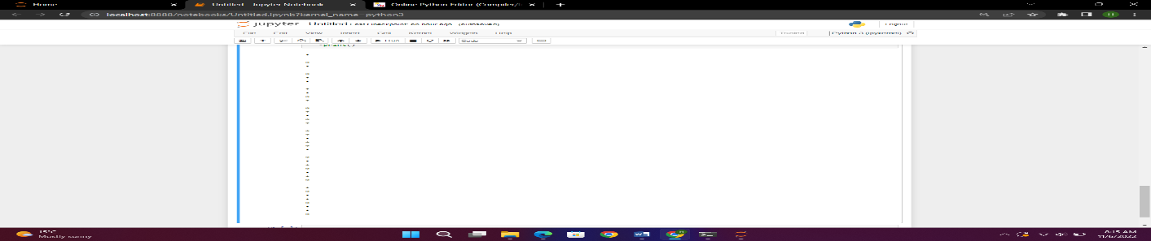

What is the term used to refer to code blocks that appear inside other code blocks as in the above program?

*Answer:*

block-structured programming language.

**_________________________________________________________________________**

## **Exercises are complete**

Save this logbook with your answers. Then ask your tutor to check your responses to each question.